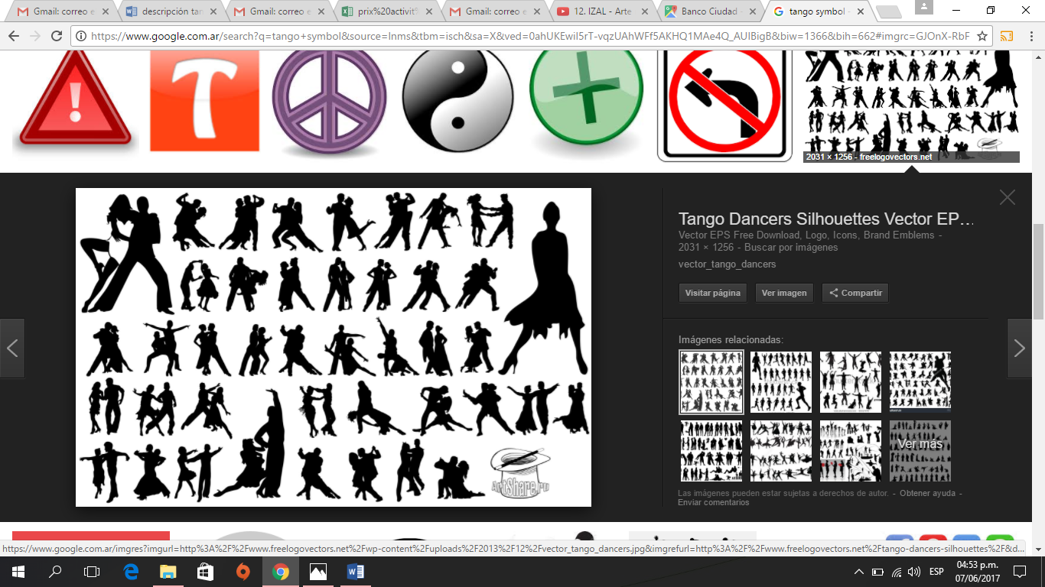 Planifica Tu show de tango with nosotros

|  |
| --- |
| Homero Manzi |
| [Résultat de recherche d'images pour "esquina homero manzi"](https://www.google.fr/url?sa=i&rct=j&q=&esrc=s&source=images&cd=&cad=rja&uact=8&ved=0ahUKEwiF4s6Y07HVAhVJhJAKHcMnDPAQjRwIBw&url=https://www.pinterest.com/casasdetango/esquina-homero-manzi/&psig=AFQjCNEyp8iqcqYD_SNgc6MDGVJr6qxLkw&ust=1501526186125992)  Inserting image... | | **One of the oldest Tango Houses of Buenos Aires at 160 years old** it is a symbol of 1940s urban culture.  Presenting a **Traditional and classical tango show well loved by locals.**   |  |  | | --- | --- | | Place | Avenida San Juan 3601, Boedo | | Transfer | central area (Recoleta, San Telmo, Palermo, microcentro, etc...) | | **Price** | **900 pesos** | | Pick up | 8pm-8.45pm | | Class | None | | Dinner | 9pm | | Menu | 4 starter and main course options and 2 desert options | | Drinks | Still or sparkling water, juice, or unlimited beer, red wine (one bottle every 2 persons) | | Show | 10pm | | Length | 1hr 30min | | Payment | cash or credit card (with 10% fees) | | Closed | / |   Kids policy  Until 3 years old : 95 pesos  Between 4 and 10 years old* : 550 pesos  *Option show* only : 460 pesos  *Only show with pick-up*  : 560 pesos  Pick-up : 8pm – 8.45pm | |
| Piazzolla |
| Résultat d’images pour piazzola TANGO SHOW | | Astor Piazzolla theater was **inaugurated in 1915** located in an amazing Art Nouveau underground made by **luxury material of that era**. An amazing setting and here you will take a journey through tango from the traditional tango through to the symphonic and contemporaneous ones of today. All while enjoying some fine dining.   |  |  | | --- | --- | | Place | Florida 165, Galeria Güemes | | Transfer | Pick up and drop off at/to central hotels (for **Palermo hotel** : **100 pesos extra**) | | **Price** | **1 400 pesos** | | Pick up | With Class :  6.45pm (Palermo) or 7pm (central hotels)  Without Class :  7.45pm (Palermo) or 8pm (central hotels) | | Class  Dinner | 8pm-8.30pm  8.30pm | | Menu | 3 options of starters, 4 options of main course and 3 options of deserts | | Drinks | Free wine of bodega La Rural, beer, sparkling or still water. Tea and coffee. | | Show | 10pm | | Length | 1hr 20min | | Payment | cash or credit card (with 10% fees) | | Closed | / |   Kids policy  Until 3 years old : free  Between 4 and 11 years old : 700 pesos (+100 pesos for pick up and drop off from Palermo)  *Option only show*   * without pick up : 500 pesos * *with pick-up* + 2 drinks (1 with + 1 without alcohol)*   : 850 pesos  *\*(Palermo area only includes transfer back to the hotel paying 100 pesos extra)*  Pick-up : 9pm-10.30pm | |
|  | |  | |
| Madero Tango | | | | |
| Résultat d’images pour madero tango | You will come to love tango in one of the most **modern buildings** in Argentina offering the stunning view of Puerto Madero during the night. With a show consisting of more than 30 artists accompanied by a narrator - telling the history of tango through different songs, music and pictures. This one is not to be missed for those wishing to know the origins of tango!   |  |  | | --- | --- | | Place | Alicia Moreau de Justo y Brasil | | Transfer | Pick up and drop off (at/to every hotel in Buenos Aires) | | Pick up | 7.45pm – 8.30pm | | Dinner | 8.30pm | | Show  Length  Payment  Closed | 8.45pm  1hr 20min  cash or credit card  Tuesday | | Executive dinner & show | | | Price  Menu  Drinks | 900 pesos  4 options of each course including bife de chorizo (sirloin steak)  Still or sparkling water (1 bottle per person), or a bottle of wine every 2 persons. | | Placement | Lateral or oblique | | Dinner & show VIP | | | Price  Menu  Drinks | 1250 pesos  6 options of each course including Bife de chorizo (steak sirloin)  Still or sparkling water, free beer, free wine or champagne | | Placement  Extra | From the 6th row in front of the stage  DVD and 30min tango class at 00.00 | | Dinner & show premium | | | Price  Menu  Drinks | 1600 pesos  7 options of each course  Free : Still and sparkling water, beer, wine, champagne. | | Placement | Individual table : 1st to 5th row in front of the stage | | Extra | Picture, DVD and 30min tango class at 00.00 | | Kids policy  Until 3 years old : free  Between 3 and 12 years old : -50% | | | |
| El viejo almacén | | | | |
|  | In a cultural heritage listed tango house of 1969 enjoy El viejo almacén! In its cozy yet ambient atmosphere it presents a passionate tango show with a touch of folkloric dance.   |  |  | | --- | --- | | Place | Avenida Independencia 299, San Telmo | | Transfer | Pick up and drop off (at/to every hotel in Buenos Aires) | | Price | 58 USD : Only show with transfer  64 USD : Only show with transfer and empanadas | | Pick up | 8.30pm – 9pm: From Palermo  9pm – 9.30pm : From central hotels and Recoleta | | Dinner | 10pm | | Menu | 2 empanadas per person during the show in the 2nd option | | Drinks | In the 2 options : 2 Drinks per person during the show | | Show  Length  Payment  Closed | 10pm  1hr 40min  cash or credit card  / | |  | | | Kids policy  Until 3 years old : free  Between 3 and 12 years old : -50% | | | |
| Café de los angelitos | | | | |
|  | **A symbol of more than 100 years of Buenos Aires’s history** having hosted bouts of political and famous artists of the 20th century, the character is booming here! Come and enjoy Tango of the **highest international standard**.   |  |  |  | | --- | --- | --- | | Place | Avenida Rivadavia 2100 | | | Transfer | Pick up and drop off (at/to every hotel in Buenos Aires) | | | Price | 85 USD : Dinner & show platea  190 USD : Dinner & show VIP  58 USD : Only show with transfer | | | Pick up | 8pm : Dinner show  9.15pm : only show | | | Dinner | 8.30pm | | | Menu | Different options of starters, main course and deserts to choose depending of the chosen menu | | | Drinks | In every menu (except from *only show* which doesn’t include drinks) all drinks are free (wine, beer, soft drinks and coffee). The wines change with the chosen menu, and **the VIP option includes champagne.** | | | Show  Length  Payment  Closed | 10.15pm  1hr 20min  cash or credit card  / | |  | | | Kids policy  Until 3 years old : free  Between 3 and 12 years old : -50% | | | |
| Esquina Carlos Gardel | | | | |
|  | Situated at the former hotel and restaurant “**Chanta cuatro**” where Carlos Gardel regularly gathered with his friends to enjoy a night out, as you should to!  More than 100 years old later, the Esquina Carlos Gardel, still boasts stunning architecture and an ambience from a past time. Come and relieve the luxurious and sophisticated tango from the golden age.   |  |  |  | | --- | --- | --- | | Place | | Carlos Gardel 3200, Abasto | | Transfer | | Pick up and drop off (at/to every hotel in Buenos Aires) | | Pick up | | 8pm – 8.30pm | | Dinner | | 9pm | | Show  Length  Payment  Closed  Drinks  Menu | | 10pm  1hr 30min  cash or credit card  /  In every menu (except only show) drinks are free (wine, beer, soft drinks) and coffee. The wine change with the chosen menu, and **the VIP option includes a glass of champagne.**  Different options of starters, main course and deserts to choose depending of the chosen menu | | Dinner-show platea | | | | Price  Placement | | 120 USD  Ground floor | | Dinner-show VIP | | | | Price  Pick-up  Placement | | 240 USD  8.30pm  Exclusive sector with a panoramic view on the ground floor. Tables are individual | | Only show platea with transfer | | | | Price  Drinks  Pick up | 80 USD  San Felipe Wine – Bodega La Rural. Still or sparkling water, beer and coffee.  9pm – 9.30pm | | |  | | | | Kids policy  Until 3 years old : free  Between 3 to 12 years old : - 50% | | | |  | | | | |
| Rojo tango | | | | |
|  | Come and enjoy world class tango accompanied by world class food!  Situated in the **Cabaret** of Faena Hotel, in Puerto Madero, Rojo Tango presents a stunning performance displaying to you the history of tango with the slightest hint of modernity. All while you enjoy an unforgettable meal prepared by the head chef from El Bistró del Faena.   |  |  | | --- | --- | | Place | Martha Salotti 445, Puerto Madero | | Transfer | Pick up and drop off (at/to every hotel in Buenos Aires) | | Price | 270 USD Dinner show  200 USD Only show with transfer | | Pick up | 7.45 : Dinner show  9pm – 9.30pm : Only show | | Dinner | 8.30pm | | Menu  Drinks | 3 options of each course to choose  Drinks are free in every menu (Terrazas Reserva Malbec and Chardonnay wine, Champagne Baron B, still and sparkling water, Nespresso coffee). | | Show  Length  Payment  Closed | 10pm  1hr 25min  cash or credit card  / | | |